121Advisor – FitBot Custom Adapters

Chen Kwai Thung

58 minutes ago

**Contents**

* [Custom Adapter](https://tfs.121advisor.com:8080/tfs/121ProjectCollections/121%20Wiki/_wiki/wikis/121-Wiki.wiki?pagePath=%2F121Advisor%20%252D%20FitBot&wikiVersion=GBwikiMaster#custom-adapter)
  + [MacroResolver Adapter](https://tfs.121advisor.com:8080/tfs/121ProjectCollections/121%20Wiki/_wiki/wikis/121-Wiki.wiki?pagePath=%2F121Advisor%20%252D%20FitBot&wikiVersion=GBwikiMaster#**macroresolver-adapter**)
  + [Video Adapter](https://tfs.121advisor.com:8080/tfs/121ProjectCollections/121%20Wiki/_wiki/wikis/121-Wiki.wiki?pagePath=%2F121Advisor%20%252D%20FitBot&wikiVersion=GBwikiMaster#**video-adapter**)
  + [Link Adapter](https://tfs.121advisor.com:8080/tfs/121ProjectCollections/121%20Wiki/_wiki/wikis/121-Wiki.wiki?pagePath=%2F121Advisor%20%252D%20FitBot&wikiVersion=GBwikiMaster#**link-adapter**)
  + [Image Adapter](https://tfs.121advisor.com:8080/tfs/121ProjectCollections/121%20Wiki/_wiki/wikis/121-Wiki.wiki?pagePath=%2F121Advisor%20%252D%20FitBot&wikiVersion=GBwikiMaster#**image-adapter**)
  + [Form Adapter](https://tfs.121advisor.com:8080/tfs/121ProjectCollections/121%20Wiki/_wiki/wikis/121-Wiki.wiki?pagePath=%2F121Advisor%20%252D%20FitBot&wikiVersion=GBwikiMaster#**form-adapter**)
  + [Suggest Adapter](https://tfs.121advisor.com:8080/tfs/121ProjectCollections/121%20Wiki/_wiki/wikis/121-Wiki.wiki?pagePath=%2F121Advisor%20%252D%20FitBot&wikiVersion=GBwikiMaster#**suggest-adapter**)

Custom Adapter

**MacroResolver Adapter**

MacroResolver Tag is use to process macro expressions in SIML.

* Example of apply transformation using macro  
  Code:  
  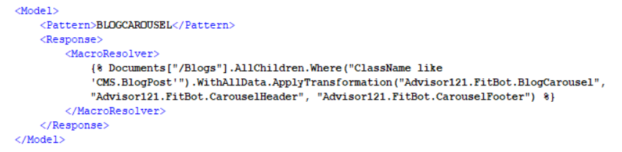  
  UIUX:  
  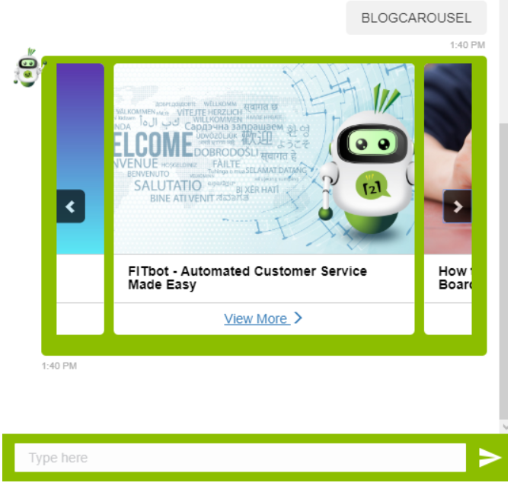
* Example of getting data from custom table with macro  
  Code:  
  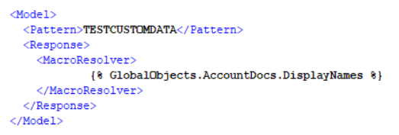  
  UIUX:  
  

**Video Adapter**

Video tag to embed a 3rd party video like YouTube.  
Tag Attributes: **Name**, **Source**.

* Example  
  Code:  
  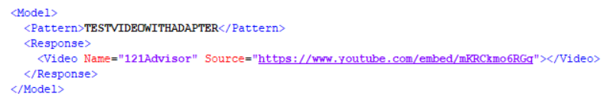  
  UIUX:  
  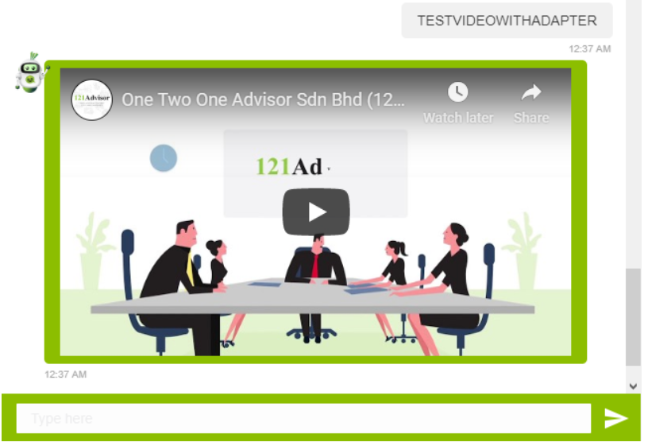
* Transformation  
  Page types > Advisor121.FitBot > transformations > BotMessageVideo
* Macro value in transformation

| **Name of tag attribute** | **Macro Value Name** |
| --- | --- |
| Source | VideoUrl (string) |
| Name | VideoName (string) |

**Link Adapter**

Link tag to defines a hyperlink.  
Tag Attributes: **Url**, **Title**.

* Example  
  Code:  
  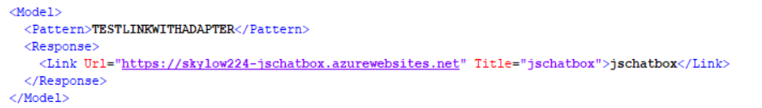  
  UIUX:  
  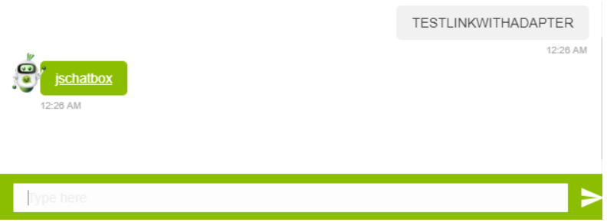
* Transformation  
  Page types > Advisor121.FitBot > transformations > BotMessageLink
* Macro value in transformation

| **Name of tag attribute** | **Macro Value Name** |
| --- | --- |
| Url | LinkUrl (string) |
| Title | LinkTitle (string) |
| (Link Content) | LinkContent (string) |

**Image Adapter**

Image tag to defines an image in SIML.  
Tag Attributes: **Type**, **Alt**, **Title**, **Source**.

Type: To define an image output format with Base64 or File Path on HTML, default is File path.

1. Image output format with file path  
   Type: **File**  
   Example code:  
   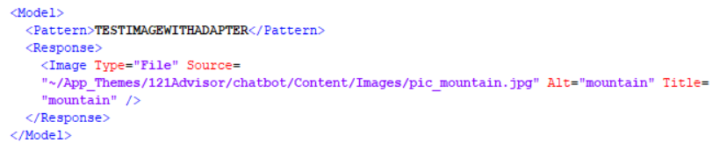  
   Example UIUX:  
   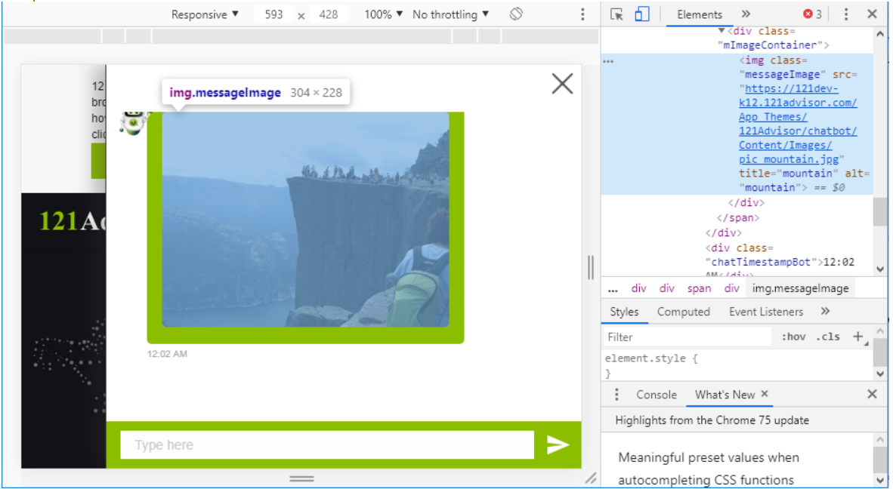
2. Image output format with Base64  
   Type: **Base64**  
   Example code:  
   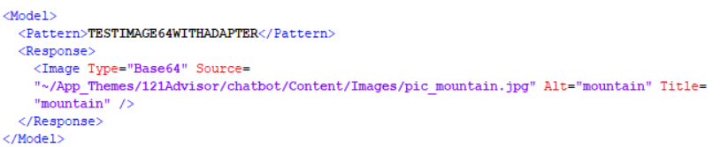  
   Example UIUX:  
   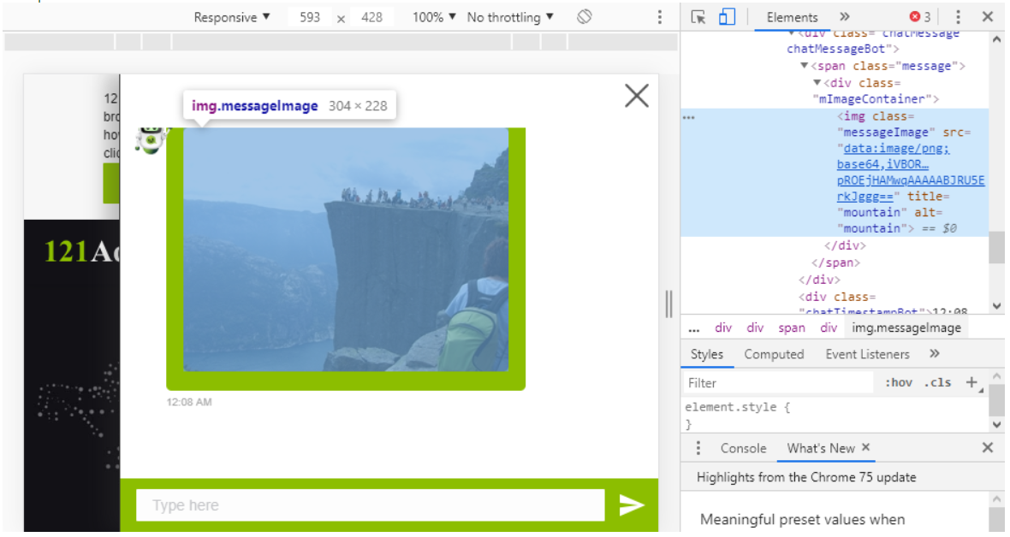

* Transformation  
  Page types > Advisor121.FitBot > transformations > BotMessageImage
* Macro value in transformation

| **Name of tag attribute** | **Macro Value Name** |
| --- | --- |
| Source | ImageUrl (string) |
| Title | ImageTitle (string) |
| Alt | ImageAlt (string) |

**Form Adapter**

Form tag defines a modal popup for on-line form and base on 2 type.  
Tag Attributes: **Type**, **Source**.  
\***Required 'Type' attribute.**

1. Popup with on click  
   Type: **PopUp_OnClick**  
   Example code:  
   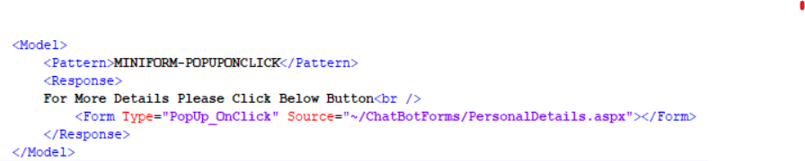  
   Example UIUX:  
   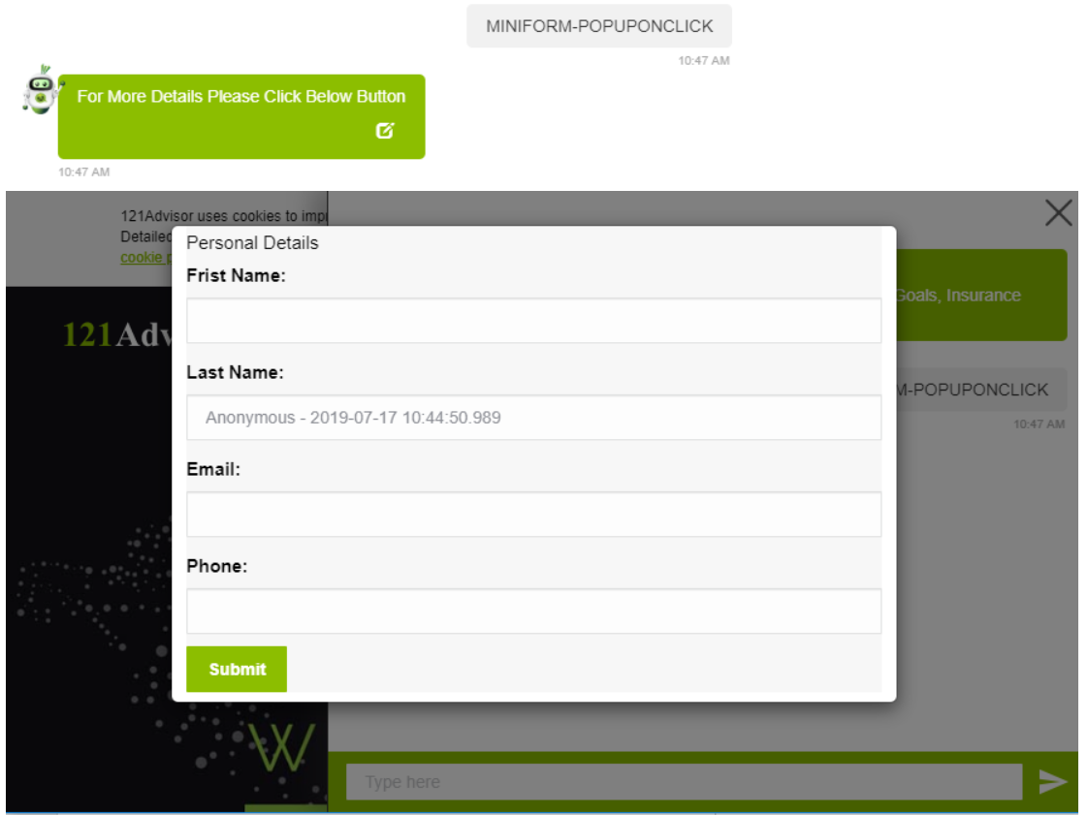
2. Popup with directly  
   Type: **PopUp**  
   Example code:  
   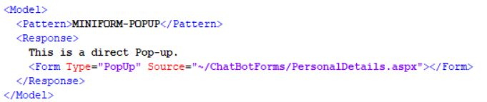  
   Example UIUX:  
   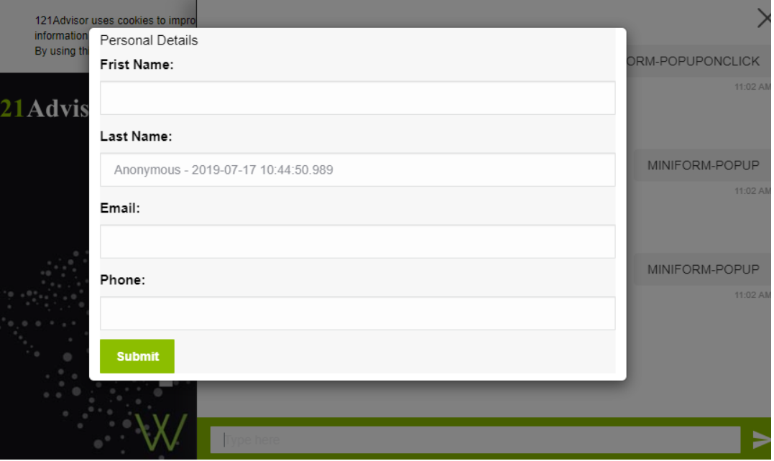

* Transformation  
  Page types > Advisor121.FitBot > transformations > BotMessageVideo
* Macro value in transformation

| **Name of tag attribute** | **Macro Value Name** |
| --- | --- |
| Source | FormURL (string) |
| Type | FormType (string) |

**Suggest Adapter**

Suggest tag defines Suggest hints/Quick reply in FitBot.  
Tag Attributes: **Type**, **Name**  
Sub Elements tag: **Button**  
\***Required 'Type' attribute.**

1. Suggest button below a message content.   
   Type: **OnMessage**  
   Example code:  
   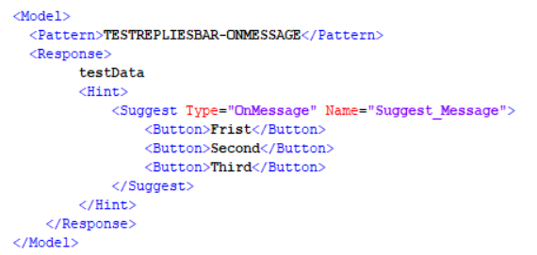

Example UIUX:  
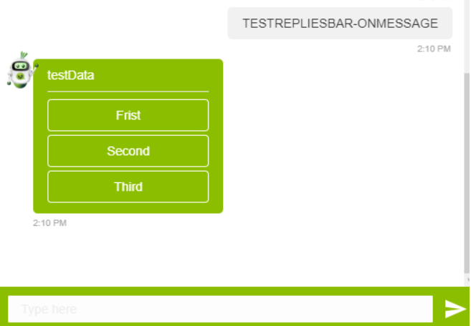

1. Suggest button on reply bar  
   Type: **OnBottom**  
   Example code:  
   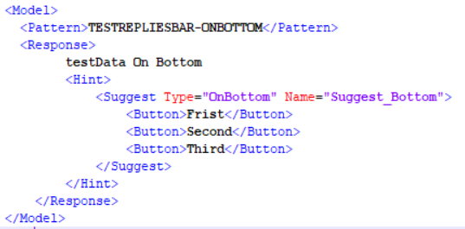  
   Example UIUX:  
   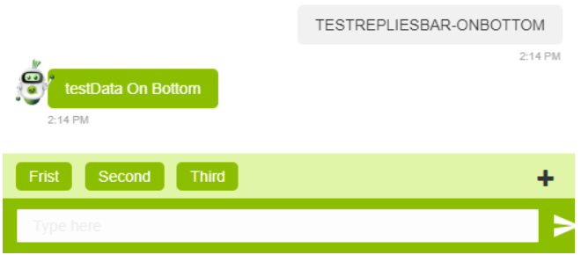

* Transformation  
  Page types > Advisor121.FitBot > transformations > BotMessageSuggest
* Macro value in transformation

| **Name of tag attribute** | **Macro Value Name** |
| --- | --- |
| Type | SuggestType (string) |
| Name | SuggestName (string) |
| (Button content value) | ButtonContentList (array) |
| (Button amount) | ButtonContentCount (int |